TryCatchWrapper63

Table of Contents
TryCatchWrapper63 1
Required Knowledge Prerequisites 1
Overview 2
Key Features 2
Primary Use Case 3
TryToReturn Method Explained 3
Parameter Details 3
Execution Flow 4
The Usage Example 4
Logging Helper Tool 6

Required Knowledge Prerequisites
C# Generics
- https://learn.microsoft.com/en-us/dotnet/csharp/fundamentals/types/generics
- https://www.tutorialsteacher.com/csharp/csharp-generics

C# Action and Func Delegates
- https://learn.microsoft.com/en-us/dotnet/api/system.action
- https://learn.microsoft.com/en-us/dotnet/api/system.func
- https://www.bytehide.com/blog/action-in-csharp-tutorial
- https://www.bytehide.com/blog/func-keyword-csharp

C# operator default
- https://learn.microsoft.com/en-us/dotnet/csharp/language-reference/operators/default

Overview
TryCatchWrapper63 is a foundational class designed to standardize exception handling and logging behavior across methods that frequently require try/catch blocks. It centralizes repeated logic to improve maintainability, reduce duplicated error-handling code, and ensure consistent logging throughout data access layers.
This class is most commonly inherited by repository classes because repository methods execute Stored Procedures and Functions in SQL Server, where exceptions may occur due to external infrastructure, configuration conditions, or unexpected runtime failures.
Typical scenarios where this base class is beneficial:
- Exceptions cannot be prevented using validation or conditional checks.
- Error-handling logic is repeated across many methods.
- Exceptions must be logged consistently.

Key Features
The class introduces four reusable wrapper methods:
Methods | Description
TryExecute | Executes code without returning a value.
TryToReturn<T> | Executes a delegate and returns a result of type T
TryExecuteAsyncTask | Async version of TryExecute
TryToReturnAsyncTask<T> | Async version of TryToReturn<T>

Additionally, the class exposes three status properties:
- public bool IsError { private set; get; }
- public string ErrorMessage { private set; get; }
- public Exception Exception { private set; get; }

A private logger defined via constructor dependency injection is used to record errors:

public TryCatchWrapper63(ILogger logger)
{
_logger = logger;
}

Primary Use Case
The TryCatchWrapper63 class is most commonly used within repository classes. Repository methods interact directly with SQL Stored Procedures and Functions, where runtime exceptions are frequently encountered due to external dependencies, such as:
- Invalid database connection string
- Database unavailable or unreachable (network issues)
- Exceptions thrown within SQL code (Stored Procedure or Function)
To address these scenarios, the shared base class RepositoryBase inherits from TryCatchWrapper63, enabling all repository methods to:
- Wrap each SQL execution in a standardized try/catch block
- Capture and process exceptions consistently
- Execute common, reusable logic inside the catch block (logging, flag updates, etc.)

TryToReturn Method Explained
The following explanation focuses specifically on the TryToReturn method. The other methods— TryExecute, TryExecuteAsyncTask and TryToReturnAsyncTask —operate using the same underlying principles and execution flow.
protected T TryToReturn<T>(
string logString,
Func<T> funcToTry,
Func<T> funcForCatch = null,
[CallerFilePath] string callerFilePath = "",
[CallerLineNumber] int callerLineNumber = 0
)

Parameter Details
Parameter | Purpose
logString | A descriptive log message typically containing method name and parameters.
funcToTry | Delegate executed inside the try block
funcForCatch (optional) | Custom recovery execution inside catch. Overrides default handling.
callerFilePath (optional - autogenerated) | Identifies the file from which the call originated. Automatically populated.
callerLineNumber (optional - autogenerated) | Identifies the line number where the call occurred. Automatically populated.

Execution Flow
- Attempt execution of funcToTry.
- If successful, return the function result.
- If an exception occurs:
  - If funcForCatch is NOT provided:
    - Process exception via internal handler
    - Return default(T)
  - If funcForCatch IS provided:
    - Assign internal properties
    - Return funcForCatch() result

By default, the system uses a custom logger implementation, ErrorLogTxtFileLogger : ILogger, which writes exception details to an ErrorLog.txt file located in:
SixtyThreeBits.Web → bin → Debug → net[version] → App_Data → ErrorLog.txt

The Usage Example
The example below does not represent a real-world scenario. It is used purely for demonstration purposes to illustrate how the TryToReturn method operates.
Download TryCatchWrapper63Demo project from GIT. https://github.com/sixtythreebits/TryCatchWrapper63Demo.git
This console application demonstrates how Calculator how class is inherited from TryCatchWrapper63 and wraps Division and in TryToReturn to catch and exception, which will automatically
- Set IsError flag to true
- Set ErrorMessage
Check calculator class methods, how Division is wrapped in TryToReturn.
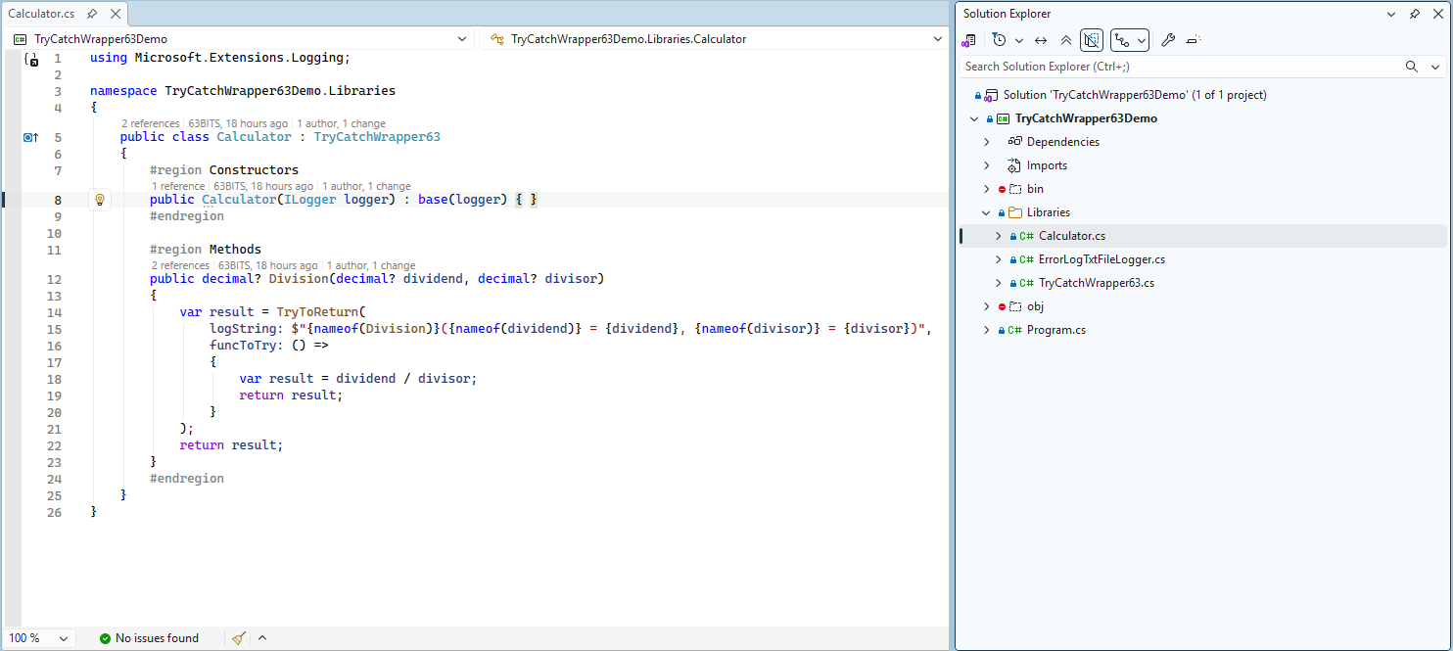

Check Main method, how Division is called and error is handled. displayErrorMessage and showErrorLogTxtFile methods are created purely for demonstration purposes only, to display error message in console application.
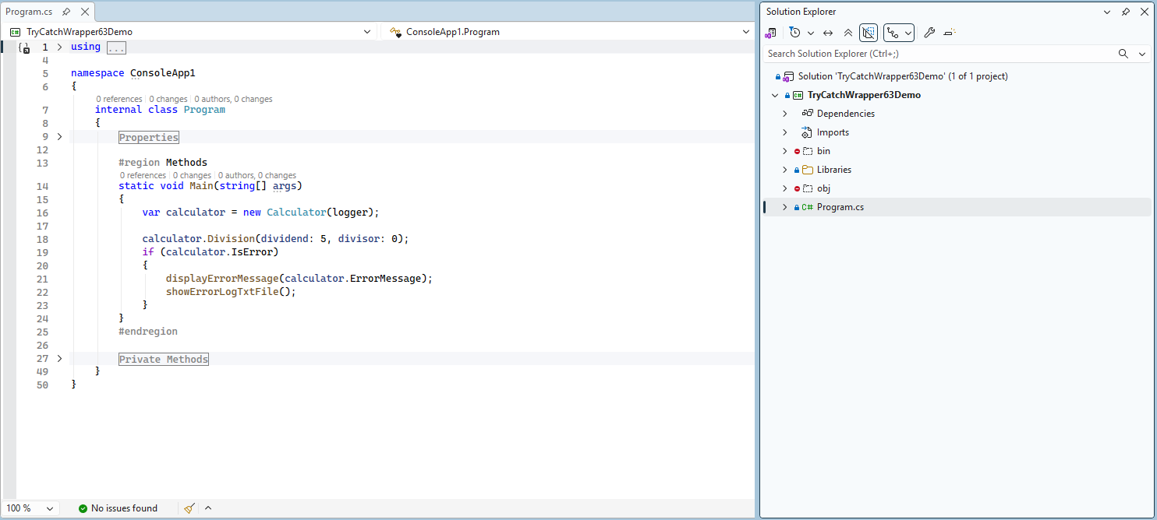

calculator.Division(dividend: 5, divisor: 0); Method call will gracefully catch exception and produce log record in
the ErrorLog.txt file.

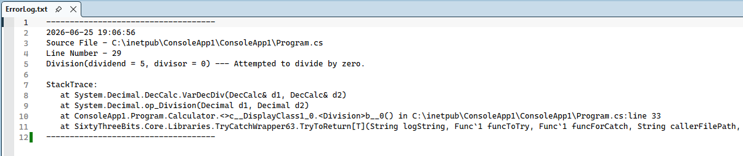

Logging Helper Tool
A helper utility automatically builds formatted log strings from method signatures:
http://helpers.63bits.com
Copy and paste you method signature into the text field and click Generate Log String button.
